Trusted Adults & Youth Voices in Exeter
Peer Action Collective (PAC) Research Report
In Exeter, the impact of youth violence and social exclusion continues to shape the lives of young people across the city. Over the past two years, the Peer Action Collective (PAC) Exeter has worked closely with young people to better understand these challenges and identify meaningful solutions. Through a youth-led approach, we have created spaces for open dialogue, enabling young people to share their experiences and insights in environments where they feel respected and heard.
Our research has focused on uncovering the root causes of the issues affecting young people in Exeter, with a particular emphasis on the role of trusted adults in their lives. By amplifying youth voice and engaging directly with communities, we aim to influence decision-makers at both local and regional levels. The goal is to bridge the gap between young peoples lived experiences and the systems that shape their futures, ensuring access to safety, opportunity, and support.
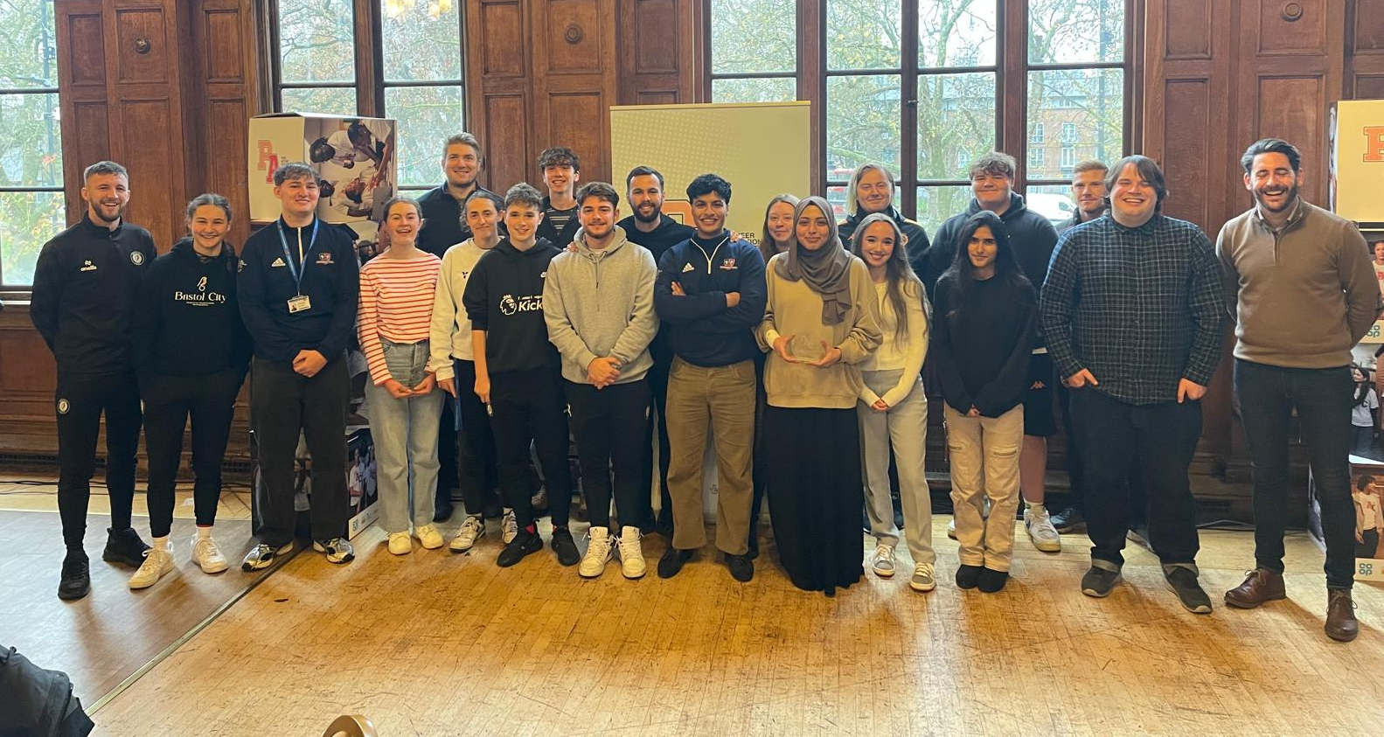



Table of Contents

What is the Peer Action Collective?……………………………………….…Page 3
Why Exeter? ..........................................................................................Page 4
Summary ………………………………………………………………………………Page 5
Who are we? .........................................................................................Page 6
Method………………………………………………………………………………….Page 7
Characteristics of a Trusted Adult: Key quotes .................................Page 8
Where Young People Find Trusted Adults ..........................................Page 10
Significant Barriers to Accessing Support ..........................................Page 11
Visions for Ideal Support and Spaces .................................................Page 13
Direct Quotes for Change ....................................................................Page 15
Key Recommendations……………………………………………..…………….Page 15
What are we doing to address these issues? .....................................Page 16
Conclusion and Recommendations …………...……….……………………Page 18

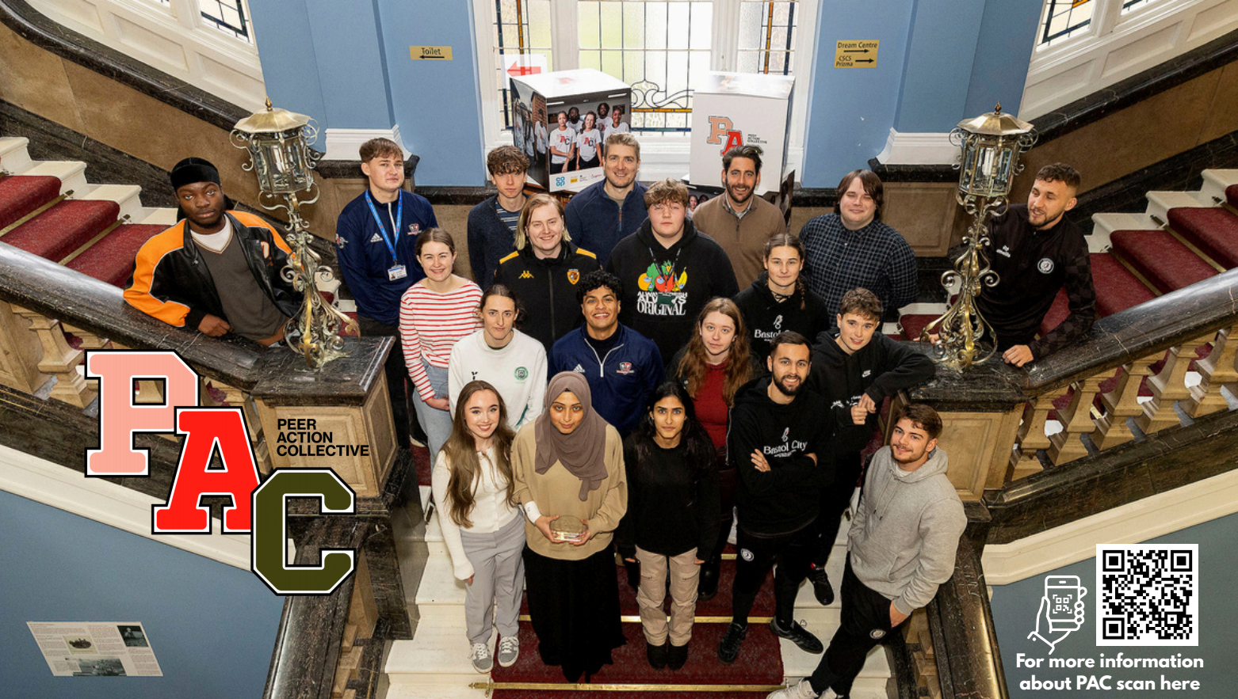
What is the Peer Action Collective?
PAC is a ground-breaking network of Peer Researchers, Social Action Leads and Changemakers.
Through the Peer Action Collective (PAC) young people are working to make their communities safer, fairer places to live. PAC is made up of a number of teams of young people across the UK, all with this shared goal. We are the Exeter PAC team.
Funded by the Youth Endowment Fund, the #iwill Fund (a joint investment between The National Lottery Community Fund and the Department for Culture, Media and Sport) and the Co-op, PAC is here to support young people to take the lead. Thanks to their funding, we've been able to launch two research projects that interconnect with each other.
Our projects originally started out as research projects, using qualitative data gathering from young people to understand their thoughts and any issues that arise within the community. After this phase we moved onto social action, this is where we present our findings and recommendations to stakeholders and put plans in place to make change!

Why does the Peer Action Collective (PAC) Exeter exist?
Experiencing serious violence has far-reaching consequences for children and young people, their families, and the wider community. In Exeter and across Devon, young people have spoken of how violence, whether direct, indirect, or environmental, affects their daily lives, wellbeing, and future opportunities.
Preventing violence requires more than short-term interventions; it demands a deeper understanding of young people’s lived realities, and evidence-based approaches that are designed with them, not for them.
Too often, young people who are most affected by violence are excluded from decision-making processes that directly shape their futures. PAC Exeter challenges this by placing young people at the centre of research, insight, and change.
At the heart of PAC Exeter is the belief that young people are the experts on their own lives. Peer research offers a participatory approach that shifts power, ensuring that knowledge production reflects the realities of those most affected.
Through PAC Exeter, young people aged 16–25 have been trained in research skills, conducting interviews, focus groups, creative workshops, and surveys with hundreds of peers aged 10–20.
Together, they have built a picture of the challenges faced by young people in Exeter, including violence, exclusion, and lack of safe spaces, while also identifying opportunities for hope and change.
Why Exeter?
Peer research is a vital tool in understanding and addressing youth violence across Devon. By placing young people at the centre of inquiry, it ensures that lived experience informs both local responses and strategic planning. This approach is particularly important in Devon, where serious violence among young people remains a growing concern.
Recent data shows that violent crime accounts for 40% of all reported offences in Devon, with over 40,800 incidents recorded between July 2024 and June 2025, a 31.4% increase compared to the previous year.
The Devon Preventing Serious Violence Strategy highlights the complexity of violence and its drivers, including peer-to-peer harm, exploitation, and violence linked to drugs, alcohol, and online spaces
Peer research enables young people to explore these issues in their own communities, offering insights that traditional methods may overlook. This participatory model not only deepens understanding but also empowers young people to co-design solutions and influence change.
In a region where youth violence is rising and systemic responses are evolving, peer research offers a pathway to more effective, equitable, and youth-informed interventions.
Summary
This report integrates findings from focus groups and interviews with young people across Devon, conducted as part of the Peer Action Collective (PAC) research project. The central aim was to explore how environments for interaction with trusted adults can be improved to provide better support and reduce youth violence. The analysis reveals a clear, consistent definition of a trusted adult among participants, significant barriers to accessing both trusted adults and mental health support, and a strong demand for safe, accessible, and non-judgmental youth spaces. Key recommendations include investing in youth hubs, reforming mental health service delivery, and providing targeted training for adults based on young peoples lived experiences.

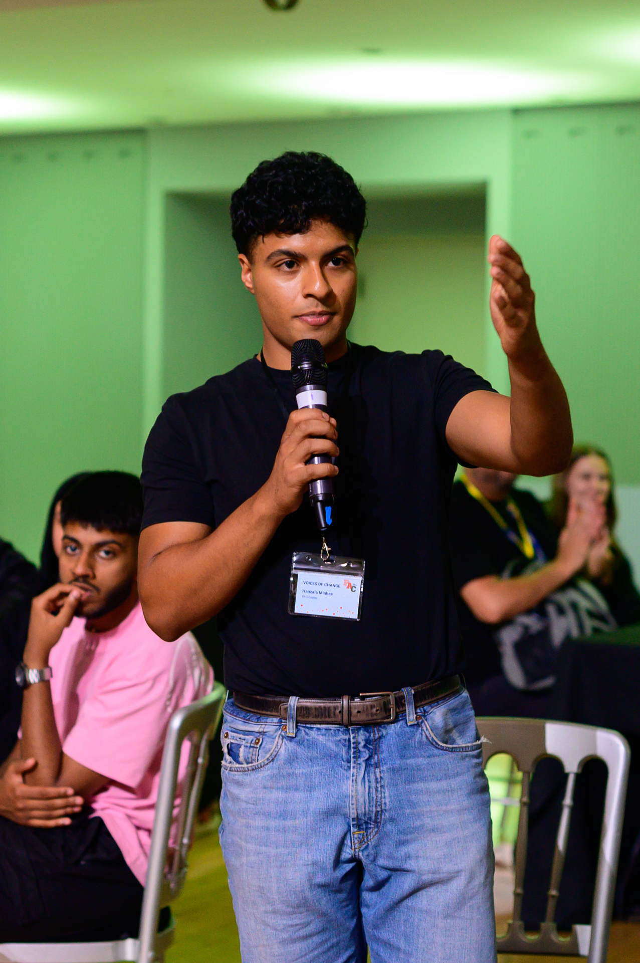

Who are we?
Finlay: “The PAC Project has helped me more than I could have ever imagined. I have learnt so many new skills whilst being a part of the project, which I can take forward into future opportunities. I am incredibly proud of the work that the Exeter City Community Trust team has done with regards to PAC and believe it will help to create meaningful change for young people in Exeter. At times, the process was tough, but we learnt from our mistakes and managed to really hone our craft in our second research project. The amount of decision makers we have been able to engage and talk to has been incredible and I hope we were able to make them really think about how youth voice could be incorporated in different settings”.



Molly: “I joined PAC to help my local community, but also to understand what is happening for the young people in and around Exeter today. The process of PAC has been tough but a lot of fun. Getting to meet new people and have experience's that without PAC I wouldn't have had at such a young age. PAC has taught me how to talk to stakeholders and policy makers. It has also given me the confidence to talk Infront of audiences, MPS and Counsellors. PAC has opened up wide opportnities for me such as potential job opportunities and gaining experience with working with young people. What I have learned from PAC I will be able to carry with me for the rest of my life”



Cheyenne: “For the past four years, I’ve worked as a sports coach, running fun and engaging sessions designed to help young people build confidence, develop skills, and enjoy being active. I joined PAC because I’m passionate about continuing to amplify young people’s voices and supporting their personal growth in different ways. I’m currently studying Criminology at the University of Exeter, and I’m passionate about continuing to work with and support young people after I graduate.
PAC has taught me the importance of listening to young people’s voices and how I can do better in creating spaces where they feel heard and valued. It’s made me more mindful of ensuring that every session I coach, or any setting I’m in with young people, is a safe and supportive space where they can express themselves freely.



Method - Exploring Trusted Adults in Exeter: A Youth-Led Research Approach
Our research focused on understanding young people’s perceptions of trusted adults and the environments that support these relationships. Building on our participatory and youth-led methodology, this phase prioritised lived experience and co-produced inquiry, ensuring that young people were central to both the design and delivery of the research.
We engaged with young people aged 12–18 from across Exeter, with a particular focus on those in alternative education settings. These environments often include young people who have experienced exclusion, marginalisation, or exposure to violence, groups whose voices are frequently underrepresented in decision-making. Our aim was to provide a platform for these young people to share their insights and shape the conversation around support and safety.
The research was delivered through a series of interactive workshops, designed and facilitated by trained peer researchers. These sessions explored themes such as trust, consistency, empathy, and confidentiality, qualities young people associate with trusted adults. Activities included scenario-based discussions, creative exercises and group reflections on real-life experiences.
To build rapport and create a safe, open environment, each workshop was preceded by an informal icebreaker visit. During these visits, the PAC Exeter team introduced the project, played games, and began forming positive relationships with participants. This approach helped foster trust and encouraged honest, meaningful contributions during the workshops.
Informed consent was obtained from all participants, with parental consent secured for those under 16. Ethical oversight was provided by the Young Foundation, ensuring that all procedures met rigorous standards for youth-led research.
All sessions were recorded and transcribed, with the resulting data analysed to identify key themes and patterns in how young people in Exeter define and experience trusted adult relationships. This insight forms the foundation of our recommendations for creating safer, more supportive environments for young people across the city.

1. Characteristics of a Trusted Adult: Key quotes
Young people provided a consistent and nuanced definition of what makes an adult "trusted."
Non-Judgemental and Unbiased: The most frequently cited quality was the ability to listen without judgement. Participants stated that a trusted adult must offer unbiased advice and not jump to conclusions.
"Someone that will give me unbiased advice."
"They don't judge you for whatever you're going through."
"She doesn't really judge whatever I might say."

Empathetic and Understanding: Trust is built through empathy, often linked to an adult's own lived experience or their professional exposure to diverse situations.
"Someone that has experience, perhaps, with their own mental health struggles so they empathise rather than just sympathise."

Approachable and Human: Young people reject scripted, formal, or clinical interactions. They value adults who are "human," relatable, and communicate in a natural, casual way.
"I feel like people could be more human... I know in my secondary school... there was this one teacher who was like my school mum. She literally helped me through my whole secondary school because she treated me like I was a human and not a student."

A negative example was given of a counsellor who simply repeated clichéd advice: "It's okay to feel sad. Take some deep breaths."
Consistent and Reliable: Trust is built over time through consistent, reliable support. A significant barrier is support that is withdrawn prematurely or is inconsistent due to staff turnover.
"I've gone there and I've been to a session and then the guy who was there quit or he got fired or something and they never rescheduled me with anyone else."
"They might not be reliable... they won't be there when you need them."

Confidential: A critical factor is the ability of an adult to keep private information confidential, whilst maintaining safeguarding standards. A breach of trust is a primary reason young people will not seek support from an adult again.
"You tell them something and then they just tell somebody else about it... It makes you feel upset and you just don't trust them."
"If they go and talk to other people about you even if you've asked them not to."

Demographic Preferences: Several participants expressed a preference for female trusted adults and younger adults who are closer to their age and can relate to their contemporary experiences.
"The closer to our age the better... people who are older, it's completely different to how it was when they were young."
"Probably a woman as well. I feel like I'd feel comfortable talking to a woman."

2. Where Young People Find Trusted Adults
The environments where trust is built are crucial. They are typically informal, familiar, and safe spaces.
Home: Parents and family members (siblings, cousins) were the most cited trusted adults.
“My cousin is a few years older than me, and I really trust them when talking about something important to me”.
School/College: Teachers, tutors, and specific support staff were vital. However, this was highly dependent on the individual teacher's personality and approach.
"My tutor... Definitely [makes it easier to have that person]."
Community Hubs: Local figures such as shopkeepers ("the boss man down the road"), sports coaches, and youth workers (e.g., from the YMCA) were identified as important figures outside the home and school.
"The boss man down the road always checks in on us (local barber) — he’s like a second dad."
Activities: Trusted adults were found through sustained participation in activities like rugby, football, musical theatre, and outdoor pursuits where shared interests foster natural relationships.
"Rugby helped me find people who actually care and treat me with respect."
Friends: Peers are a primary and preferred source of support for many, valued for their longevity and perceived safety.
"You can talk. They're on the other side. You're safe."
3. Significant Barriers to Accessing Support
Participants identified systemic and personal barriers to finding and accessing support from trusted adults and formal services.
Systemic Failures in Mental Health Services: This was a major theme. Criticisms included:
Long Waiting Lists: Described as "a joke," with waits of months or even years.
"The waiting list is crazy... by the time it's your turn to go, you could have fixed it yourself."
"Better awareness, about different mental health disorders or just disabilities in general."
The "Triage Trap": Services are perceived as only helping those in immediate, critical ("red") danger, leaving those with significant but not acute needs without support. "They just chuck you back out after."
Poor Diagnosis and Training: A lack of understanding of neurodivergence (ADHD, Autism) and LGBTQ+ issues was frequently mentioned. Conditions are often misdiagnosed as anxiety or depression. "They've only been trained about anxiety and depression."
"Bring back youth clubs, bring back trips... There need to be more opportunities for young people to do things together that's not in school and not online."
Impersonal and Scripted Interactions: Negative experiences included being given paperwork to fill in when anxious, being "locked in a soundproof box," and receiving repetitive, unhelpful advice.
Lack of Safe and Appealing Spaces: The widespread closure of youth clubs has created a vacuum. Existing clubs were often described as:
- Unsafe and Chaotic: Multiple reports of violence, poor supervision, and illicit activities (e.g., vaping indoors) creating an unsafe environment.
"I had a chair thrown at my head... The adults would meet up in the car park and they'd just leave it. It would turn into a mess."
- "Childish" and Boring: Geared towards much younger children, with activities that hold no appeal for teenagers.
- Overwhelming: Large, noisy, and crowded environments were particularly off-putting for those who are not naturally social or who struggle with anxiety.
"I’d go if it was free and had stuff we actually want to do."
"Loads of people isn't going to help. It just makes it a bit hard."
"I’d go if it was free and had stuff we actually want to do."
- Non-Existent for Older Teens: A recurring point was that there is nothing for the "in-between" age, too old for youth clubs, too young for adult spaces like pubs.
"There's not really anything geared specifically to the in between ages from around 14-18."
Accessibility and Cost: Barriers include:
- Transport: Poor public transport in rural areas isolates young people. "It would take half a day to go and see them."
- Cost: Expenses related to gym memberships, sports clubs, travel, and private counselling were prohibitive.
- Location: Spaces need to be in safe, accessible areas near public transport links.
"It costs too much to get to places — I just stay home."
"I’d go if it was free and had stuff we actually want to do."

- Stigma and Fear: Particularly around men's mental health, and a fear of being a "burden" or being ridiculed for "minor" problems prevents young people from reaching out.
4. Visions for Ideal Support and Spaces
Young people provided clear, constructive ideas for improving support systems.
The Ideal Youth Hub/Space: Participants envisioned a modern, inclusive youth hub that would be:
- Free or Low-Cost: To ensure maximum accessibility.
- A Social Space: Somewhere to "just walk in, sit down" and be with peers, not necessarily for structured therapy.
- Activity-Based: Featuring sports, creative arts (music production, crafts), and crucially, life skills workshops (e.g., taxes, budgeting, cooking, sign language).
"Maybe it could help with... life skills... like how to do washing, taxes and stuff."
- Integrated Support: Co-locating advice services (sexual health, mental health) within a casual social space to reduce stigma and improve access.
- For Everyone: While LGBTQ+ safe spaces were supported, there was a strong desire for unified spaces where everyone feels accepted, avoiding segregation. "Everywhere should be safe for those people."
- Well-Supervised and Safe: Adequate, engaged staff to ensure a safe and respectful environment for all attendees.
- Age-Appropriate: Suggestions included having specific sessions for different age groups to ensure activities and the social environment are relevant.
Improved Mental Health Service Delivery: Young people want:
- Walk-In Access: The ability to access immediate, informal support without a long referral process.
- Better Trained Staff: Professionals with knowledge beyond anxiety and depression, specifically in neurodivergence and LGBTQ+ issues.
"Educate boys... A lot of boys aren't taught about periods and female health."
- Active Listening: Support that moves beyond scripted questions and truly listens to individual needs. "Asking more questions rather than just being like it's this."
- Varied Communication Methods: Options for support that include anonymous text/phone-based services for those who find face-to-face interaction intimidating.
"Over the phone is comfortable because different people are working differently."
The Role of Adults: Participants want adults in their lives (teachers, support workers) to:
- Build Real Relationships: Take a genuine interest in students' lives and hobbies, not just their academic results.
- Be Proactive: Notice changes in behaviour and offer support without waiting to be asked.
- Respect Confidentiality: While understanding safeguarding limits, young people need to know that conversations won't be shared unnecessarily, especially with parents, if it could make the situation worse.
- Receive Better Education: Teachers need training that goes beyond the "very, very basics to get them their qualifications" and includes a deeper understanding of mental health, neurodivergence, and the specific challenges faced by young people today.
"Educate the teacher... they should be better educated as to what needs to be done and why."

5. Direct Quotes for Change
When asked what they would tell those in power, participants' messages were clear:
On Education Systems: "Change the entire school system... it's absolutely horrible" and "Better awareness, about different mental health disorders or just disabilities in general."

Systemic Pressures: "The fact that you're never going to get on the property ladder can be a serious pressure."

On Funding & Spaces: "Bring back youth clubs, bring back trips... There need to be more opportunities for young people to do things together that's not in school and not online."

On Mental Health Services: "Sort it out... It's the fact that every bit of CAMHS... they just chuck you back out after."

Provide training for teachers, youth workers, and other community figures on the principles of being a "trusted adult", active listening, non-judgement, confidentiality, and building genuine, human connections. Training should be co-designed with young people who understand their needs best, ensuring relevance and empathy in support systems.

Key Recommendations:
Invest in Modern Youth Hubs: Fund the creation of free, accessible youth hubs co-designed with young people. These should be social spaces that integrate advice services, life skills workshops, and appealing activities for older teenagers, with a strong emphasis on safety and qualified supervision.
Reform Mental Health Training and Delivery: Mandate advanced training for CAMHS, school counsellors, and support staff on neurodivergence and LGBTQ+ issues. Develop more informal, walk-in, and anonymous support services to complement traditional clinical models.
Empower and Train Adults: Provide training for teachers, youth workers, and other community figures on the principles of being a "trusted adult", active listening, non-judgement, confidentiality, and building genuine, human connections.
Improve Transport and Accessibility: Address rural isolation by reviewing and improving public transport links for young people, particularly in Devon and Somerset.
Listen and Co-Design: Continue to engage young people directly in the design and delivery of the services and spaces intended for them, ensuring they are relevant and effective.

What are we doing to address these issues?
Social Action Summary
Building on the findings from our youth-led research into trusted adults and safe spaces in Exeter, the Peer Action Collective (PAC) Exeter has launched a series of social action initiatives aimed at addressing the key challenges identified by young people.

Interactive Map of Youth Provisions in Devon
To improve access to safe and engaging environments, we have developed an interactive map that highlights youth provisions across Devon. This tool allows young people to easily locate nearby youth clubs, activity hubs, and support services. The map is designed to be user-friendly and accessible, helping to reduce barriers related to transport, awareness, and isolation.
You can find more information here: https://exetercct.org/interactiveprovisionmap/
We also created advertising and media in collaboration with young people taking part in our social action work, which have been shared across Devon via email, social media and physical copies, such as stickers.




Youth Panel with Safer Devon
In collaboration with Safer Devon, we are establishing a youth panel that will actively participate in local decision-making. This panel will ensure that young voices are heard in shaping policies and initiatives that affect their lives. By embedding youth perspectives into strategic planning, we aim to create safer, more inclusive communities.

Trusted Adult Workshop
We have designed and delivered a workshop for trusted adults across Devon, including teachers, learning coaches, teaching assistants, and members of our own team at Exeter City Community Trust. The workshop focuses on the key qualities identified by young people, empathy, consistency, confidentiality, and non-judgmental support. Through interactive activities and scenario-based learning, adults are equipped with the tools to build stronger, more supportive relationships with young people.
These social action initiatives represent our commitment to turning research into meaningful change. By amplifying youth voices and fostering collaboration, we are working towards a future where every young person in Exeter and Devon feels safe, supported, and empowered.
Scan here to access our toolkit --
Conclusion and Recommendations
PAC Exeter’s social action initiatives mark a pivotal moment in reshaping youth support systems across Devon. By translating peer-led research into tangible change, the team has demonstrated how youth voice can drive innovation and inclusivity in public services.
The creation of an interactive map of youth provisions in Devon empowers young people to independently discover safe, accessible spaces tailored to their interests and needs. This tool not only enhances visibility of existing services but also identifies gaps, guiding future investment and outreach efforts.
The partnership with Safer Devon to establish a youth panel embeds young voices directly into decision-making processes. This initiative ensures that policies and programs are shaped by lived experience, fostering more responsive and equitable systems of support.
Equally transformative is the trusted adult workshop, which equips educators, coaches, and support staff with the insights needed to build meaningful, empathetic relationships with young people. By sharing findings from peer-led research, the workshop bridges the gap between adult intentions and youth expectations, promoting environments of trust, safety, and mutual respect.
Together, these initiatives form a cohesive strategy that not only addresses immediate challenges but lays the foundation for long-term cultural change. PAC Exeter’s work exemplifies the power of youth-led action in creating a future where all young people feel heard, supported, and empowered to thrive.

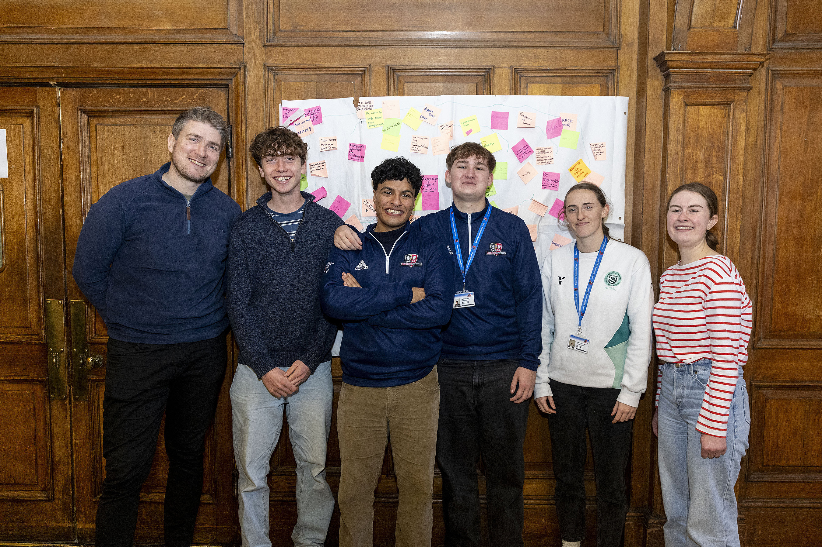

For any more information, please contact chris.may@ecct.co.uk

